**How to create 3D model in Blender and upload it to Cesium ion?**

1. First, open the software Blender. Select GIS -> Web geodata -> Basemap to select the study area (Lexis Hibiscus Port Dickson).

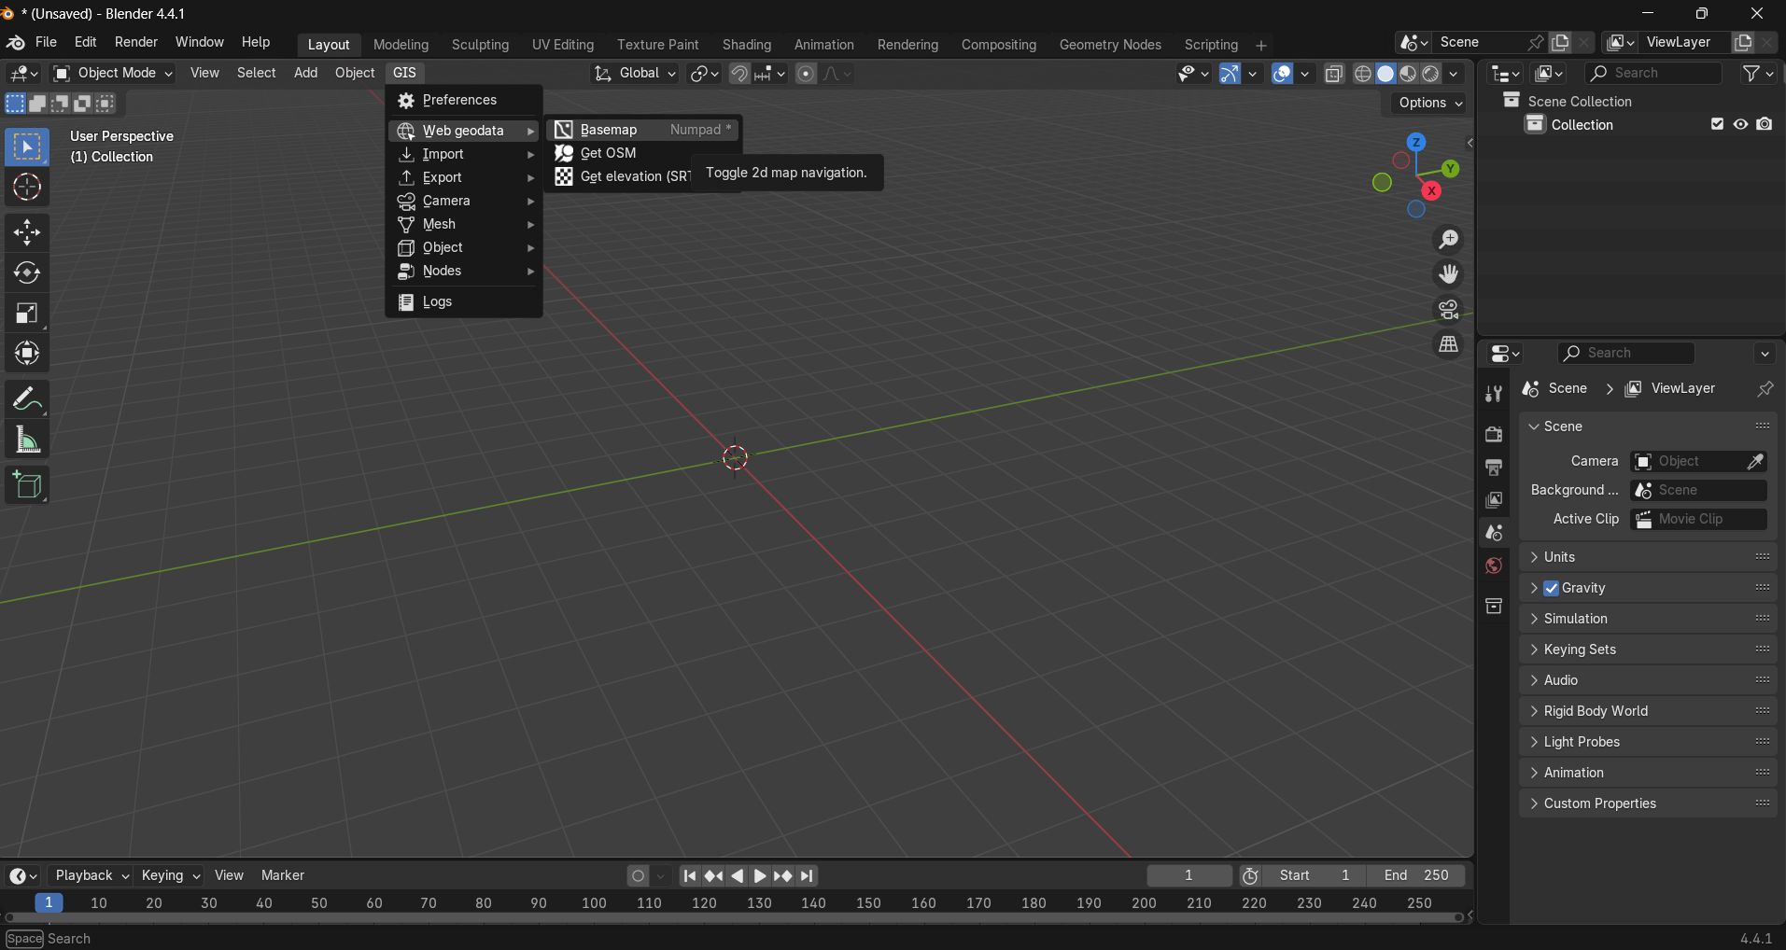

2. After clicking **Basemap,** this dialog will appear then click OK.

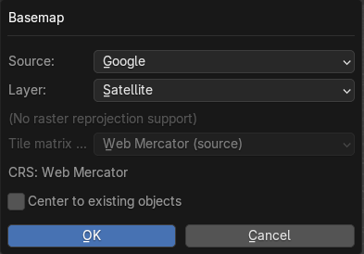

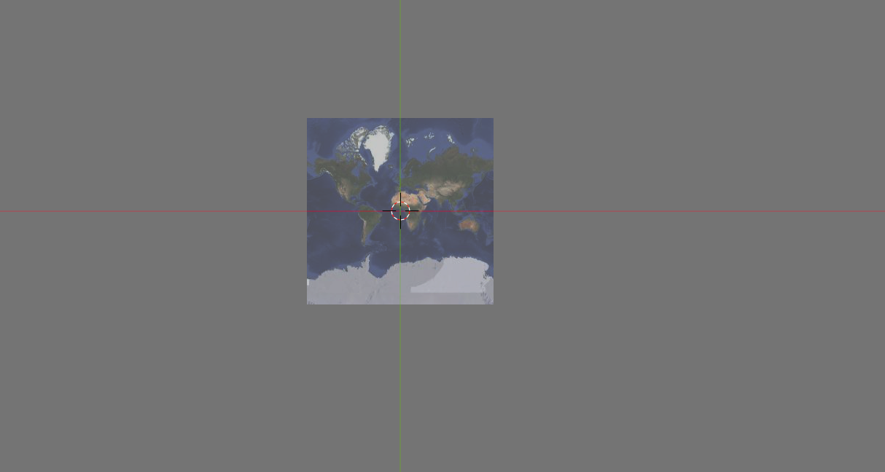

3. Ctrl + G to locate to the location by searching.

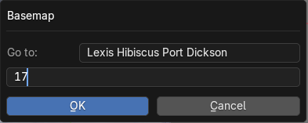

4. Adjust to the satisfied area, click E to extract the basemap

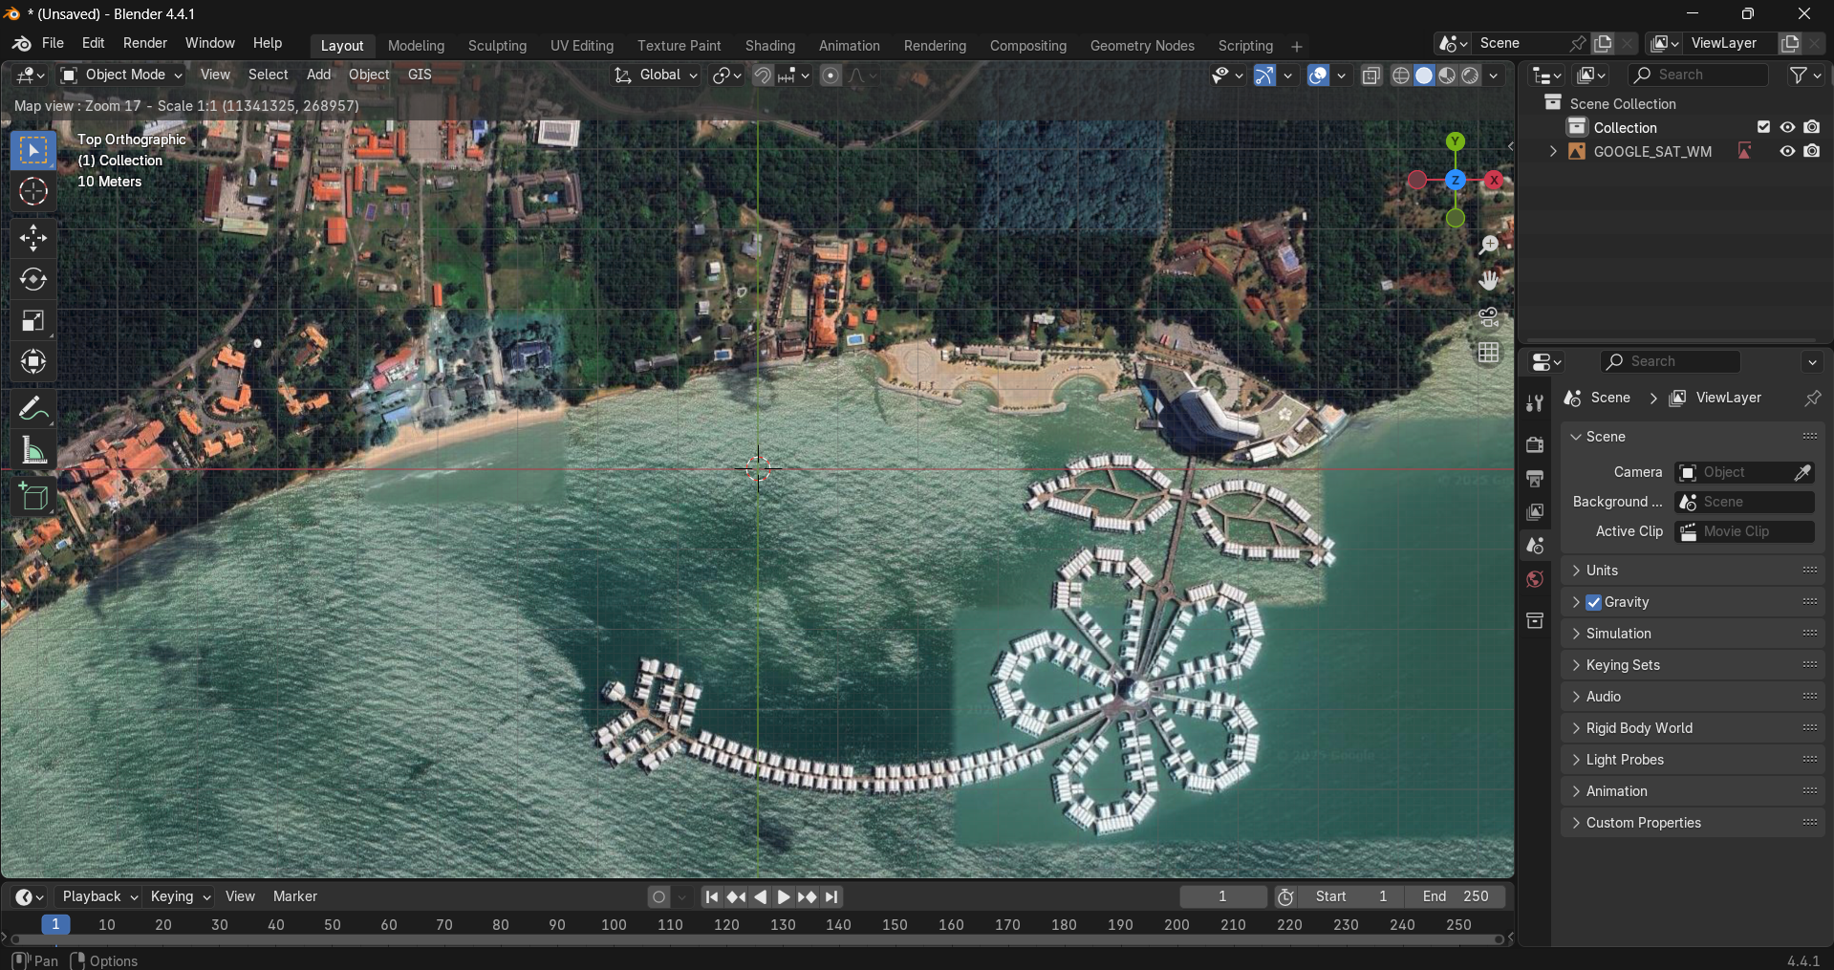

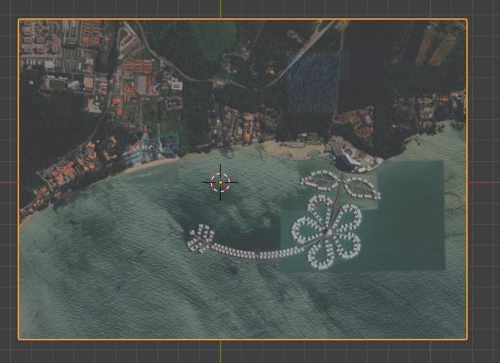

5. Click GIS, select Web geodata and then Get elevation (STRM). Select the server: Marine-geo.org GMRT

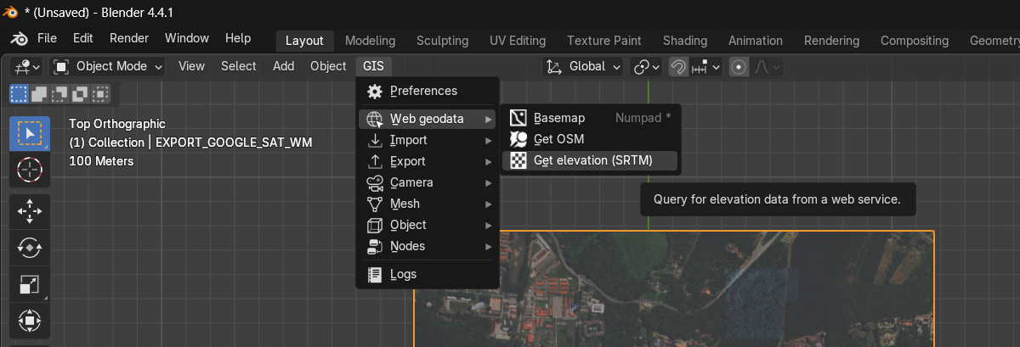

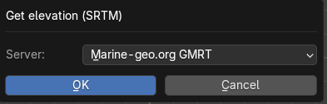

6. Click again GIS, select Web geodata and then Get OSM.

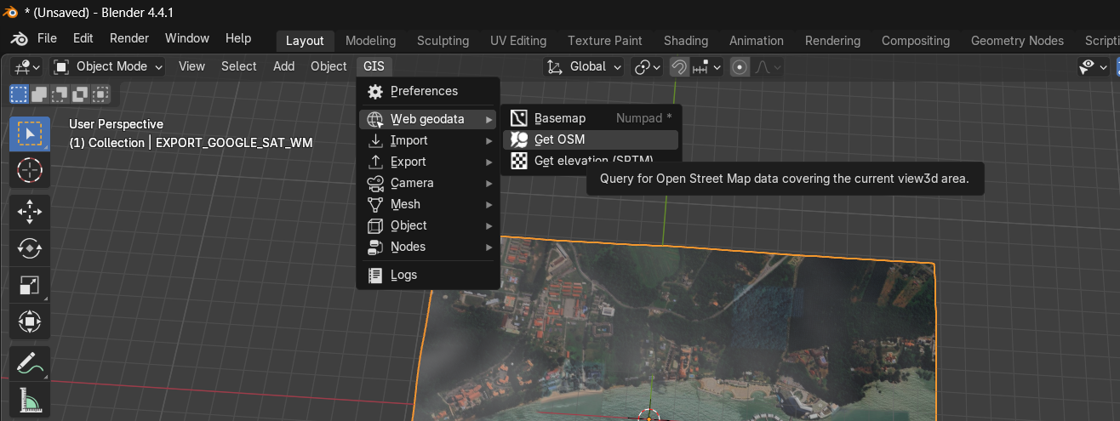

In the dialog Get OSM, select building. Tick ‘Elevation from object’ and ‘Separate objects’. Then, click OK.

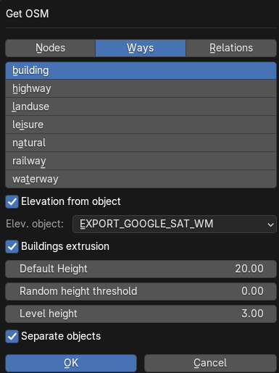

7. The 3D buildings of study area are extruded.

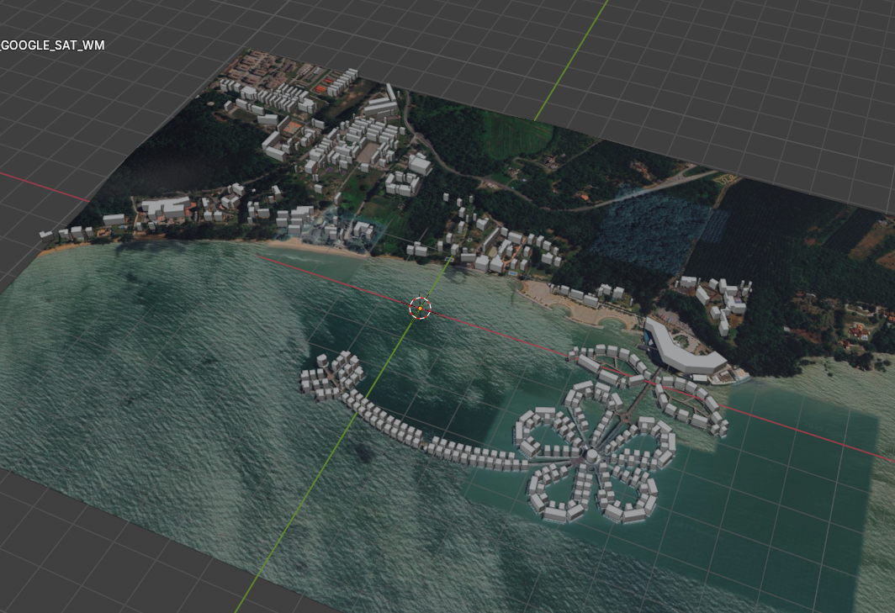

8. Next, to export the file click File -> Export -> Collada (.dae) (Legacy).

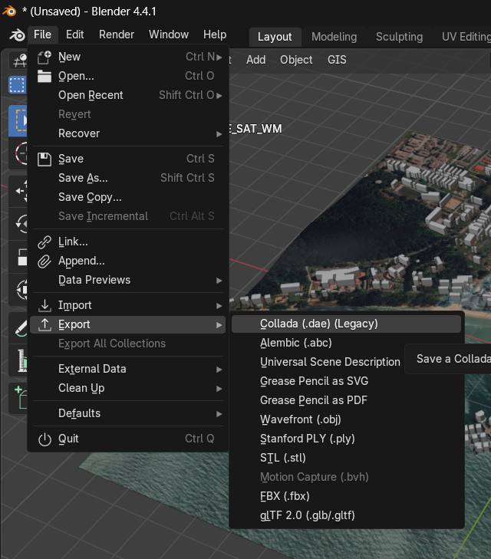

9. Upload the COLLADA file to Cesium ion as 3D Tileset.

10. Uploaded 3D Tileset in Cesium ion.

